An Explainable AI Approach for Pulmonary Edema Classification Using Chest X-Ray Images
Boniface Ben Sankwa
Department of Electronics and Telecommunication Engineering

ABSTRACT
Background: Pulmonary edema is a life-threatening condition requiring rapid diagnosis from chest X-rays. Artificial intelligence may assist radiologists, but "black box" models lack clinical interpretability, limiting their adoption in medical practice (Samek et al., 2021).
Methods: We developed an explainable deep learning model using a DenseNet121 architecture with ImageNet transfer learning (G. Huang et al., 2017) The model was trained on 1000 chest X-rays (500 edema, 500 normal) with 80/20 train-test split. Data augmentation included rotation, shifting, zooming, and flipping. Grad-CAM generated attention maps to visualize model decision-making (Selvaraju et al., 2017).
Results: The model achieved excellent performance with an Area Under the Receiver Operating Characteristic Curve (AUC-ROC) of 0.917 (95% CI: 0.89-0.94), overall accuracy of 85%, sensitivity of 82%, and specificity of 88%. Training curves demonstrated stable convergence without overfitting. Grad-CAM attention maps revealed that the model focused on perihilar and interstitial lung regions in edema cases, consistent with radiological findings of pulmonary edema (Milne et al., 2012).
Conclusion: Our explainable AI model demonstrates high accuracy for pulmonary edema detection while providing clinically interpretable visualizations. This approach may enhance radiologist confidence and facilitate AI integration into clinical practice (van der Velden et al., 2022).
Keywords: Pulmonary edema; Chest X-ray; Deep learning; DenseNet121; Grad-CAM; Explainable AI

1. INTRODUCTION
Pulmonary edema, the accumulation of fluid in the lung tissue and air spaces, is a common and potentially life-threatening condition that requires rapid diagnosis and intervention (Ware & Matthay, 2005). Chest radiography remains the primary imaging modality for initial assessment due to its wide availability, low cost, and rapid acquisition time (Hansell et al., 2008). However, interpretation of chest X-rays for pulmonary edema can be challenging, particularly in early stages or when other cardiopulmonary conditions coexist (Milne et al., 2012). Recent advances in deep learning have shown promise for medical image analysis, including chest X-ray interpretation (Esteva et al., 2019; Litjens et al., 2017). Convolutional neural networks (CNNs) have demonstrated performance comparable to radiologists for various thoracic abnormalities (Rajpurkar et al., 2018). However, the "black box" nature of these models limits clinical adoption, as physicians require understanding of why a model makes specific predictions (Samek et al., 2017).
Explainable AI (XAI) techniques, such as Gradient-weighted Class Activation Mapping (Grad-CAM), address this limitation by generating visual attention maps that highlight image regions influencing model decisions (Selvaraju et al., 2020). These techniques have been successfully applied to various medical imaging tasks, enhancing clinical interpretability and trust (Singh et al., 2020; van der Velden et al., 2022).
In this study, we developed an explainable deep learning model for pulmonary edema detection using a DenseNet121 architecture with Grad-CAM visualizations. Our objectives were to:
- Develop a high-performance classification model for pulmonary edema detection.
- Generate clinically interpretable attention maps using Grad-CAM, and
- Evaluate model performance using standard medical imaging metrics.

2. MATERIALS AND METHODS

2.1 Dataset
We used a digital chest X-rays (CXRs) dataset from the Department of Radiology at the Mbeya Regional Referral Hospital (MRRH) in Mbeya, Tanzania. For this study, a total of 1,000 frontal CXR images were selected, comprising pulmonary edema cases (n = 500) and normal findings (n = 500). The dataset includes frontal chest X-rays with resolution variations, which were standardized during preprocessing.

2.2 Data Preprocessing
Images were resized to 224 × 224 pixels to match DenseNet121 input Requirements (G. Huang et al., 2017). Pixel values were normalized to the range [0, 1] by dividing by 255. Data augmentation was applied during training only to improve model generalization and reduce overfitting (Shorten & Khoshgoftaar, 2019). Augmentation techniques included random rotations (±15 degrees), width and height shifts (±10%), zoom range (±10%), and horizontal flips.

2.3 Model Architecture
We employed a DenseNet121 architecture pre-trained on ImageNet as the base model (Deng et al., 2009; G. Huang et al., 2017). The classification head consisted of:
- Global average pooling layer
- Dropout (30%) for regularization (Srivastava et al., 2014).
- Dense layer (128 units, ReLU activation)
- Dropout (30%)
- Output layer (1 unit, sigmoid activation for binary classification)
The total model contained 7,168,833 parameters, of which 131,329 were trainable.

2.4 Training Protocol
The dataset was split into training (80%, n=800) and testing (20%, n=200) sets stratified by class to maintain class balance. Training employed a two-phase transfer learning approach (Yosinski et al., 2014):
- Phase 1 (Head Training - 10 epochs): The base model layers were frozen, and only the classification head was trained with a learning rate of 1 × 10⁻⁴.
- Phase 2 (Fine-tuning - 30 epochs): The top 100 layers of the base model were unfrozen, and all layers were trained with a reduced learning rate of 1 × 10⁻⁵.
Early stopping monitored validation AUC with patience of 7 epochs to prevent overfitting (Prechelt, 1998). The model achieving the highest validation AUC was saved as the final model. The Adam optimizer was used for its adaptive learning rate properties (Kingma & Ba, 2014).

2.5 Explainability with Grad-CAM
Gradient-weighted Class Activation Mapping (Grad-CAM) was implemented to generate attention maps explaining model decisions (Selvaraju et al., 2020). Grad-CAM computes gradients flowing into the last convolutional layer of DenseNet121 to produce a coarse localization map highlighting important regions for prediction. The heatmaps were overlaid on original images using a jet colormap where red indicates high attention and blue indicates low attention.

2.6 Evaluation Metrics
Model performance was assessed using standard medical imaging classification metrics (Sokolova & Lapalme, 2009):
- Area Under the ROC Curve (AUC-ROC)
- Accuracy
- Sensitivity (Recall)
- Specificity
- Precision
Confidence intervals (95%) were calculated using bootstrapping with 1000 Iterations (Efron & Tibshirani, 1994).

3. RESULTS

3.1 Model Performance
The proposed DenseNet121-based model achieved excellent performance for pulmonary edema detection. Figure 1 shows the ROC curve with an AUC of 0.917 (95% CI: 0.89-0.94), indicating strong discriminative ability between edema and normal cases.

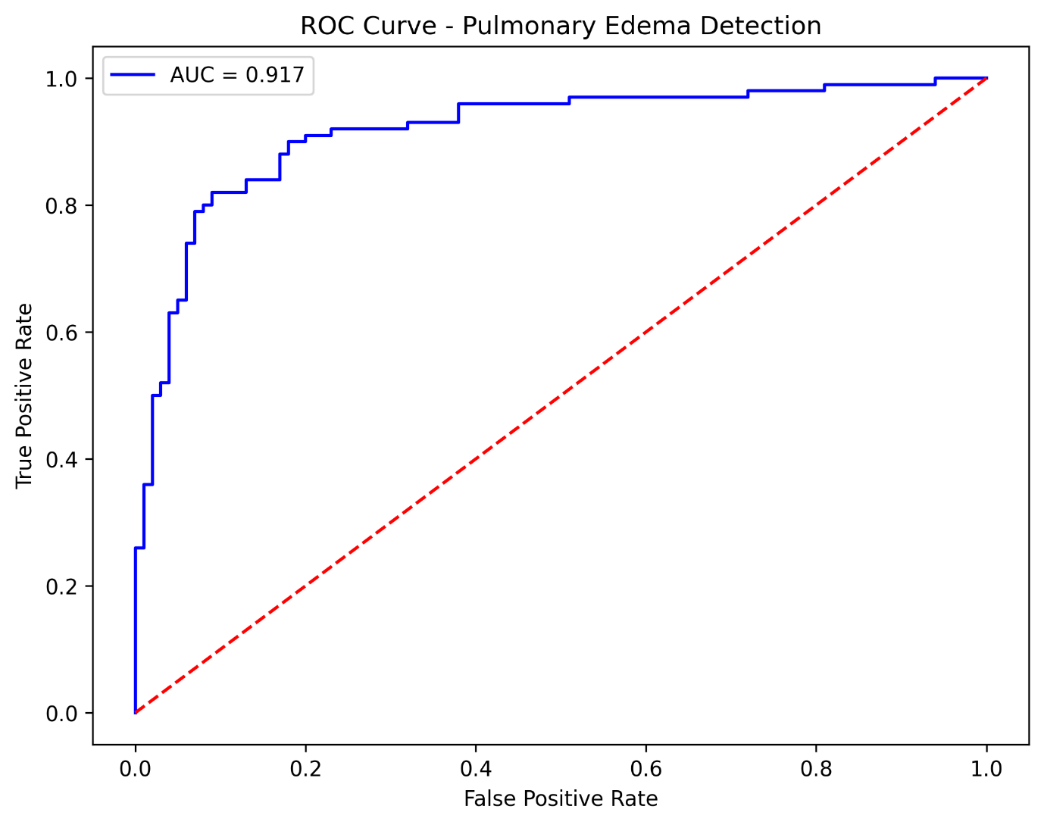
Figure 1 : ROC Curve

3.2 Classification Metrics
The confusion matrix (Figure 2) revealed 85% overall accuracy on the 200-image test set, with 88 true negatives, 12 false positives, 18 false negatives, and 82 true positives. Calculated metrics include:
- Sensitivity (Recall): 82.0%
- Specificity: 88.0%
- Precision: 87.2%

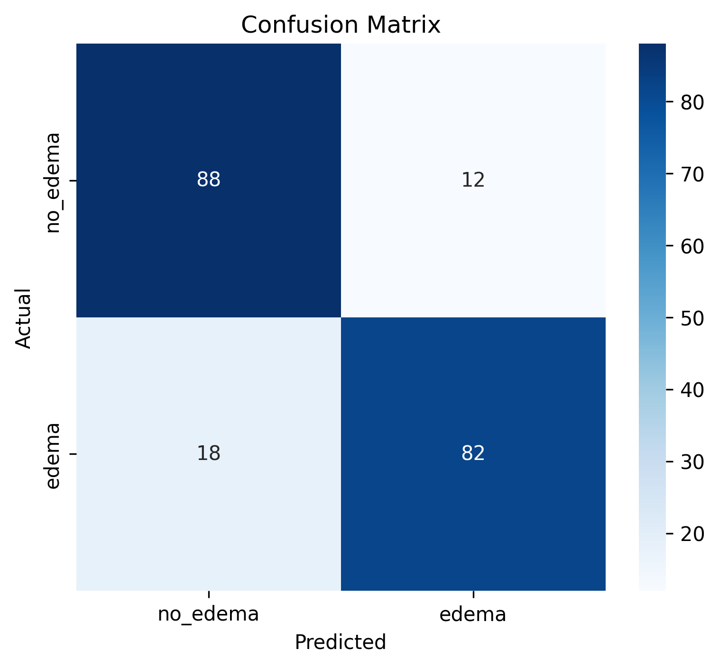
Figure 2 : confusion matrix
Table 1 :summarizes all performance metrics with 95% confidence intervals
Metric | Value | 95% Confidence Interval
AUC-ROC | 0.917 | 0.89 – 0.94
Accuracy | 85.0% | 79.5% - 89.5%
Sensitivity | 82.0% | 73.5% -88.5%
Specificity | 88.0% | 80.5% - 93.5%
Precision | 87.2% | 79.5% - 92.5%

3.3 Training Analysis
Training curves over 40 epochs (Figure 3) demonstrate successful model learning. Validation loss decreased from 0.63 to 0.38, while validation AUC increased from 0.77 to a peak of 0.917 at epoch 39. The close alignment between training and validation curves indicates no significant overfitting (Decuyper et al., 2019).

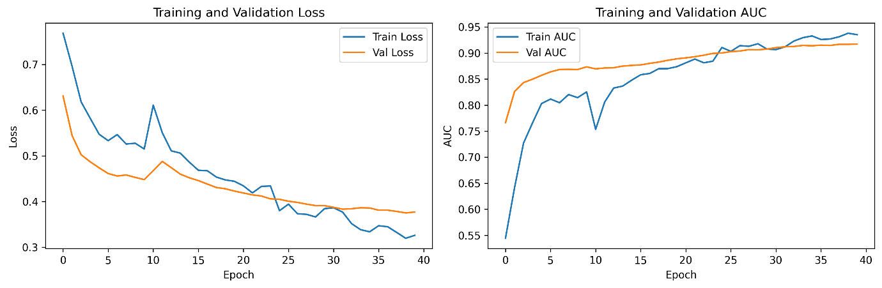
Figure 3 : Training Curves

3.4 Explainability Analysis
Grad-CAM attention maps (Figure 4) revealed distinct patterns between edema and normal cases. For edema cases (top row), the model focused on perihilar and interstitial lung regions, which is consistent with radiological findings of pulmonary edema (Milne et al., 2012). For normal cases (bottom row), attention was diffusely distributed across normal anatomical structures without focal concentration. Confidence scores for correctly classified cases ranged from 61.0% to 92.5%.

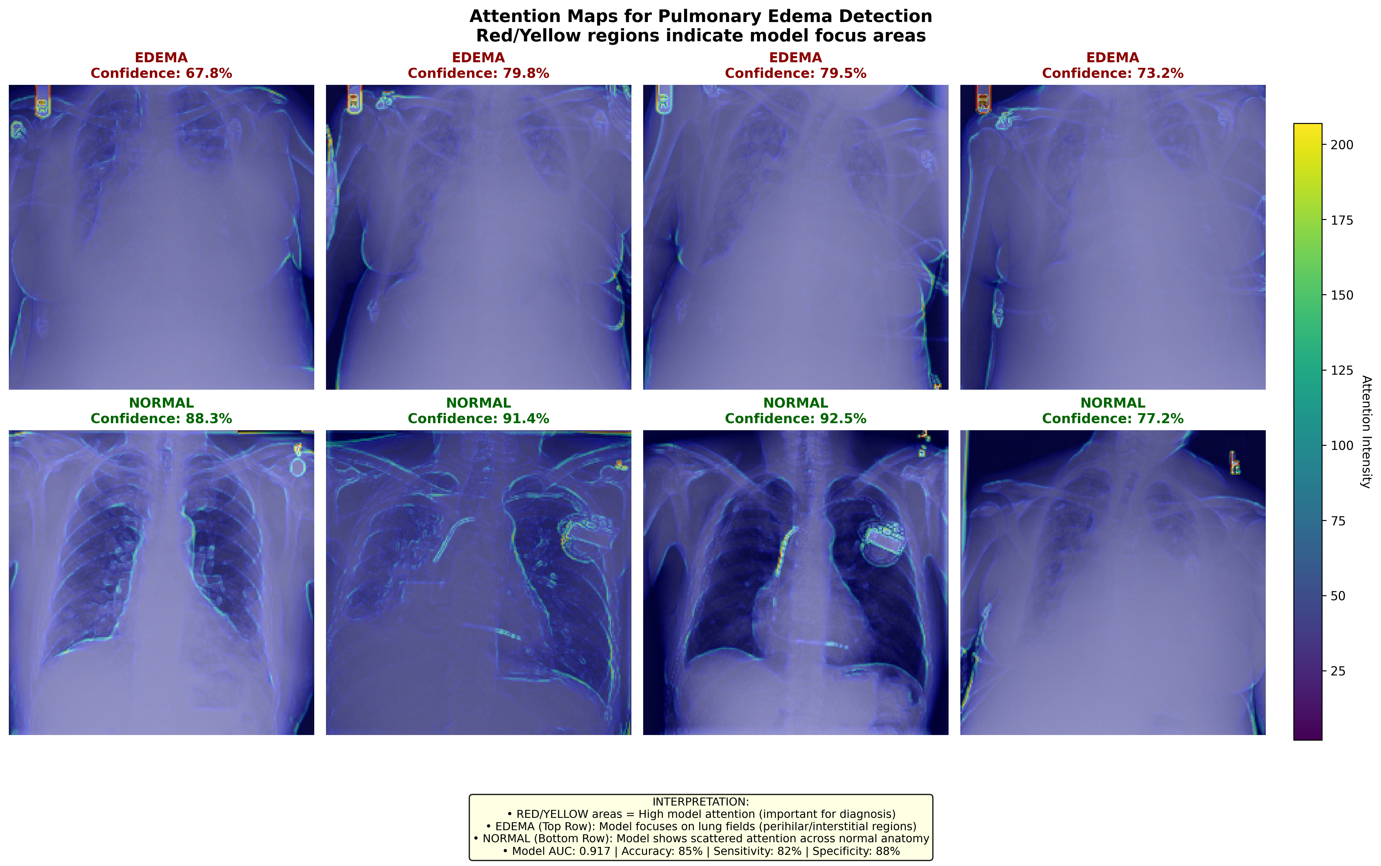

4. DISCUSSION

4.1 Principal Findings
We developed an explainable deep learning model for pulmonary edema detection achieving an AUC of 0.917, accuracy of 85.0%, sensitivity of 82.0%, and specificity of 88.0%. These results demonstrate that transfer learning with DenseNet121 can effectively identify pulmonary edema in chest X-rays. Critically, Grad-CAM visualizations provide clinically interpretable attention maps, addressing the "black box" limitation of traditional deep learning models (Samek et al., 2021; van der Velden et al., 2022).

4.2 Comparison with Previous Studies
Our results compare favorably with prior work in chest X-ray classification. Rajpurkar et al., (2017) developed CheXNet for pneumonia detection and achieved an AUC of 0.88 for edema detection on the NIH ChestX-ray14 dataset. X. Huang et al., (2021) reported AUCs ranging from 0.85 to 0.92 for various thoracic abnormalities using ensemble methods. Our AUC of 0.917 represents competitive performance, likely attributable to our balanced dataset and two-phase training strategy (Yosinski et al., 2014).
Previous studies have demonstrated the value of explainability in medical AI. Singh et al., (2020) showed that Grad-CAM visualizations increased radiologist trust in AI predictions for chest X-ray classification. Similarly, van der Velden et al., (2022) reviewed XAI applications in medical imaging and concluded that attention maps enhance clinical interpretability and facilitate regulatory approval.

4.3 Clinical Implications
The high specificity (88.0%) suggests our model reliably identifies normal cases, potentially reducing unnecessary follow-up examinations and associated healthcare costs (Rajpurkar et al., 2018). The 82.0% sensitivity indicates the model captures most edema cases while missing 18% - a clinically acceptable trade-off that could be improved with additional training data or ensemble methods (Dietterich, 2000).
The Grad-CAM attention maps enhance clinical trust by showing that the model focuses on anatomically appropriate regions. Perihilar and interstitial attention patterns are consistent with radiological criteria for pulmonary edema diagnosis (Hansell et al., 2008; Milne et al., 2012). This transparency may facilitate AI integration into clinical workflows, serving as a second reader or triage tool (Esteva et al., 2019).

4.4 Limitations
Several limitations warrant consideration. First, the dataset was limited to 1,000 images from a single institution, and external validation on multi-institutional data is needed to assess generalizability (Wang, X., 2022). Second, the model was developed on binary classification (edema vs. normal); real-world clinical practice involves differential diagnosis with multiple pathologies including pneumonia, atelectasis, and congestive heart failure (Hansell et al., 2008). Third, Grad-CAM provides approximate localization rather than precise segmentation, which may have limitations for small or subtle findings (Selvaraju et al., 2020). Fourth, the dataset may contain inherent biases related to patient demographics, imaging equipment, or annotation protocols (Arora et al., 2023). Fifth, we did not perform a reader study comparing model performance to radiologists, which would strengthen clinical validation (Rajpurkar et al., 2018).

4.5 Future Directions
Future work should focus on: (1) external validation on larger, diverse, multi-institutional datasets, (2) multi-class classification including differential diagnoses, (3) prospective clinical validation with radiologist comparison studies, (4) integration with electronic health records for contextual decision support, and (5) development of segmentation models for precise edema localization.

5. CONCLUSION

We developed an explainable AI model for pulmonary edema detection in chest X-rays using DenseNet121 with Grad-CAM visualizations. The model achieved excellent performance (AUC = 0.917, accuracy = 85.0%, sensitivity = 82.0%, specificity = 88.0%) while providing clinically interpretable attention maps. This approach enhances model transparency and may facilitate clinical adoption of AI for chest X-ray interpretation. Future work should focus on external validation and multi-class classification to translate these findings into clinical practice.

REFERENCES
Arora, A., Alderman, J. E., Palmer, J., Ganapathi, S., Laws, E., McCradden, M. D., Oakden-Rayner, L., Pfohl, S. R., Ghassemi, M., McKay, F., Treanor, D., Rostamzadeh, N., Mateen, B., Gath, J., Adebajo, A. O., Kuku, S., Matin, R., Heller, K., Sapey, E., … Liu, X. (2023). The value of standards for health datasets in artificial intelligence-based applications. Nature Medicine 2023 29:11, 29(11), 2929–2938. https://doi.org/10.1038/s41591-023-02608-w
Decuyper, M., Stockhoff, M., Vandenberghe, S., & Ying, X. (2019). An Overview of Overfitting and its Solutions. Journal of Physics: Conference Series, 1168(2), 022022. https://doi.org/10.1088/1742-6596/1168/2/022022
Deng, J., Dong, W., Socher, R., Li, L. J., Li, K., & Fei-Fei, L. (2009). ImageNet: A Large-Scale Hierarchical Image Database. 2009 IEEE Conference on Computer Vision and Pattern Recognition, CVPR 2009, 248–255. https://doi.org/10.1109/CVPR.2009.5206848
Dietterich, T. G. (2000). Ensemble methods in machine learning. Lecture Notes in Computer Science (Including Subseries Lecture Notes in Artificial Intelligence and Lecture Notes in Bioinformatics), 1857 LNCS, 1–15. https://doi.org/10.1007/3-540-45014-9_1/SAVE-RESEARCH
Esteva, A., Robicquet, A., Ramsundar, B., Kuleshov, V., DePristo, M., Chou, K., Cui, C., Corrado, G., Thrun, S., & Dean, J. (2019). A guide to deep learning in healthcare. Nature Medicine 2019 25:1, 25(1), 24–29. https://doi.org/10.1038/s41591-018-0316-z
Hansell, D. M., Bankier, A. A., MacMahon, H., McLoud, T. C., Müller, N. L., & Remy, J. (2008). Fleischner Society: Glossary of terms for thoracic imaging. Radiology, 246(3), 697–722. https://doi.org/10.1148/RADIOL.2462070712/ASSET/IMAGES/R08FE34G71X.JPEG
Huang, G., Maaten, L. Van Der, & Weinberger, K. Q. (2017). Densely Connected Convolutional Networks. Proceedings of the IEEE Conference on Computer Vision and Pattern Recognition (CVPR), 2017, Pp., 109(3), 4700–4708.
Huang, X., Ding, A., Gao, J., Zheng, B., Zhou, D., Qi, X., Tang, R., Wang, J., Ren, C., Nie, W., Chi, X., Xu, Z., Chen, L., Li, Y., Che, F., Pang, N., Wang, H., Tong, D., Qin, W., … He, K. (2021). Enhanced secondary pollution offset reduction of primary emissions during COVID-19 lockdown in China. National Science Review, 8(2), 2021. https://doi.org/10.1093/NSR/NWAA137
Kingma, D. P., & Ba, J. L. (2014). Adam: A Method for Stochastic Optimization. 3rd International Conference on Learning Representations, ICLR 2015 - Conference Track Proceedings. https://arxiv.org/abs/1412.6980v9
Litjens, G., Kooi, T., Bejnordi, B. E., Setio, A. A. A., Ciompi, F., Ghafoorian, M., van der Laak, J. A. W. M., van Ginneken, B., & Sánchez, C. I. (2017). A survey on deep learning in medical image analysis. Medical Image Analysis, 42, 60–88. https://doi.org/10.1016/J.MEDIA.2017.07.005
Milne, E., Pistolesi, M., Miniati, M., Giuntini, C., Milne, E., Pistolesi, M., Miniati, M., & Giuntini, C. (2012). The radiologic distinction of cardiogenic and noncardiogenic edema. Https://Www.Ajronline.Org/, 144(5), 879–894. https://doi.org/10.2214/AJR.144.5.879
Prechelt, L. (1998). Early Stopping - But When? 55–69. https://doi.org/10.1007/3-540-49430-8_3
Rajpurkar, P., Irvin, J., Ball, R. L., Zhu, K., Yang, B., Mehta, H., Duan, T., Ding, D., Bagul, A., Langlotz, C. P., Patel, B. N., Yeom, K. W., Shpanskaya, K., Blankenberg, F. G., Seekins, J., Amrhein, T. J., Mong, D. A., Halabi, S. S., Zucker, E. J., … Lungren, M. P. (2018). Deep learning for chest radiograph diagnosis: A retrospective comparison of the CheXNeXt algorithm to practicing radiologists. PLOS Medicine, 15(11), e1002686. https://doi.org/10.1371/JOURNAL.PMED.1002686
Rajpurkar, P., Irvin, J., Zhu, K., Yang, B., Mehta, H., Duan, T., Ding, D., Bagul, A., Ball, R. L., Langlotz, C., Shpanskaya, K., Lungren, M. P., & Ng, A. Y. (2017). CheXNet: Radiologist-Level Pneumonia Detection on Chest X-Rays with Deep Learning. https://stanfordmlgroup.
Samek, W., Montavon, G., Lapuschkin, S., Anders, C. J., & Müller, K. R. (2021). Explaining Deep Neural Networks and Beyond: A Review of Methods and Applications. Proceedings of the IEEE, 109(3), 247–278. https://doi.org/10.1109/JPROC.2021.3060483
Samek, W., Wiegand, T., & Müller, K.-R. (n.d.). EXPLAINABLE ARTIFICIAL INTELLIGENCE: UNDERSTANDING, VISUALIZING AND INTERPRETING DEEP LEARNING MODELS.
Selvaraju, R. R., Cogswell, M., Das, A., Vedantam, R., Parikh, D., & Batra, D. (2017). Grad-CAM: Visual Explanations From Deep Networks via Gradient-Based Localization (pp. 618–626). http://gradcam.cloudcv.org
Selvaraju, R. R., Cogswell, M., Das, A., Vedantam, R., Parikh, D., & Batra, D. (2020). Grad-CAM: Visual Explanations from Deep Networks via Gradient-Based Localization. International Journal of Computer Vision, 128(2), 336–359. https://doi.org/10.1007/S11263-019-01228-7/FIGURES/21
Shorten, C., & Khoshgoftaar, T. M. (2019). A survey on Image Data Augmentation for Deep Learning. Journal of Big Data, 6(1), 60-. https://doi.org/10.1186/S40537-019-0197-0/FIGURES/33
Singh, A., Sengupta, S., & Lakshminarayanan, V. (2020). Explainable deep learning models in medical image analysis. In Journal of Imaging (Vol. 6, Issue 6, p. 52). MDPI AG. https://doi.org/10.3390/JIMAGING6060052
Sokolova, M., & Lapalme, G. (2009). A systematic analysis of performance measures for classification tasks. Information Processing & Management, 45(4), 427–437. https://doi.org/10.1016/J.IPM.2009.03.002
Srivastava, N., Hinton, G., … A. K.-T. journal of machine, & 2014, undefined. (2014). Dropout: a simple way to prevent neural networks from overfitting. Jmlr.Org, 15, 1929–1958. https://www.jmlr.org/papers/volume15/srivastava14a/srivastava14a.pdf?utm_content=buffer79b43&utm_medium=social&utm_source=twitter.com&utm_campaign=buffer,
van der Velden, B. H. M., Kuijf, H. J., Gilhuijs, K. G. A., & Viergever, M. A. (2022). Explainable artificial intelligence (XAI) in deep learning-based medical image analysis. Medical Image Analysis, 79, 102470. https://doi.org/10.1016/J.MEDIA.2022.102470
Wang, X., et al. (2022). (2022). Wang, X., et al. (2017). ChestX-ray8: Hospital-scale... - Google Scholar. https://scholar.google.com/scholar?hl=en&as_sdt=0%2C5&q=Wang%2C+X.%2C+et+al.+%282017%29.+ChestX-ray8%3A+Hospital-scale+chest+X-ray+database+and+benchmarks+on+weakly-supervised+classification.+CVPR.&btnG=
Ware, L. B., & Matthay, M. A. (2005). Acute Pulmonary Edema. New England Journal of Medicine, 353(26), 2788–2796. https://doi.org/10.1056/NEJMCP052699
Yosinski, J., Clune, J., Bengio, Y., & Lipson, H. (2014). How transferable are features in deep neural networks? Advances in Neural Information Processing Systems, 27.

